9.77: a) 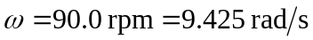
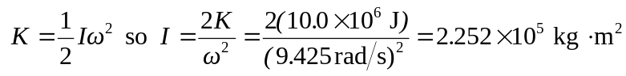
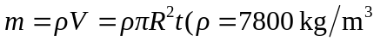is the density of iron and t=0.100 m is the thickness of the flywheel)
